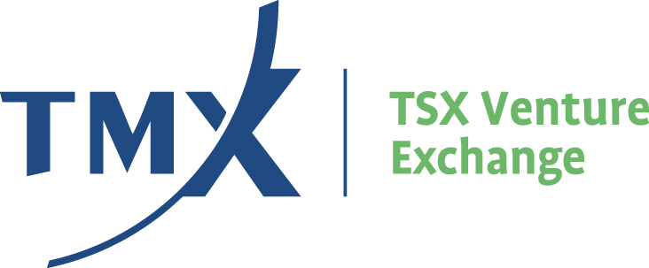

APPENDIX 3G

VALUATION STANDARDS AND GUIDELINES FOR MINERALS PROPERTIES

- Introduction

This Appendix sets out the Exchange’s expectations and requirements for a valuation of mineral properties and outlines:

- the general purpose of valuation reports;

- guidelines respecting circumstances where the Exchange will require a valuation report; and

- valuation standards, guidelines and methods that are generally acceptable to the Exchange.

Mining industry standards and guidelines for valuations and valuation reports can be found in the Canadian Institute of Mining, Metallurgy and Petroleum Standards and Guidelines for Valuation of Mineral Properties (“CIMVal”) published in February, 2003 (www.cim.org). CIMVal consists of two parts, Standards and Guidelines. The Standards are mandatory and must be followed in order for a valuation to be CIMVal compliant. The Guidelines in CIMVal are not mandatory, but are strongly recommended.

The Exchange requires that CIMVal Standards be used by Issuers and their professional advisors when preparing valuations and valuation reports on mineral properties. The CIMVal Guidelines should be followed by Issuers and their professional advisors in preparing valuation reports on mineral properties, with the exception that the valuation methods and guidelines under Section 4 Acceptable Valuation Methods and Guidelines below, must be followed.

2. General Purpose of a Valuation Report

Policy 5.4 – Escrow, Vendor Consideration and Resale Restrictions (“Policy 5.4”) differentiates between Value Securities and Surplus Securities that may be issued pursuant to a transaction. Generally, securities are deemed to be Value Securities if the supportable value of the asset or property for which the securities are being issued, equals or exceeds the deemed value of the securities to be issued. Generally, Surplus Securities are securities issued pursuant to a transaction which are not supported by a valuation method acceptable to the Exchange or for which the value of the asset is less than the deemed value of securities.

The distinction between Surplus Securities and Value Securities is important due to the difference in escrow terms applicable to Principal securities. Value Securities are subject to a shorter time period for the release of escrowed securities than are Surplus Securities.

Section 4.2 of Policy 5.4 provides for various methods that an Issuer may use to assign value for the purpose of calculating the number of Value Securities that can be issued pursuant to a transaction. In the case of mineral properties, section 4.2(d)(ii) of Policy 5.4 provides that this calculation may be made on the basis of a valuation report.

It should be noted that a valuation report for mineral properties will generally not be required in the event that an Issuer proposes to issue Surplus Securities in accordance with Policy 5.4. Surplus Securities may be reclassified as Value Securities and subject to an accelerated release schedule based on a valuation report that takes into account subsequent developments.

Whether an Issuer proposes to issue Value Securities or Surplus Securities, a Geological Report will always be required.

- Where a Valuation Report is Required

A valuation report will generally be required to support the issuance of Value Securities in the following circumstances:

- an acquisition or disposition that involves Non Arm’s Length Parties;

- a transaction that results in a Change of Control;

- a Reverse Take Over, as contemplated by Policy 5.2 – Changes of Business and Reverse Take-Overs; or

- a Reviewable Transaction or Fundamental Acquisition, as contemplated by Policy 5.3 – Acquisitions and Dispositions of Non-Cash Assets.

In general, where a transaction involves Non Arm’s Length Parties or a Related Party Transaction without a current acceptable valuation report, the deemed value of any mineral properties will be restricted to out of pocket costs.

4. Acceptable Valuation Methods and Guidelines

Valuation Methods

Most valuation methods of mineral properties are highly subjective, and often arbitrary in their application, making it difficult to obtain reproducible valuations. It is the Exchange’s view that valuation methods utilized must be appropriate to the subject and be prudently applied in order to maintain fairness and consistency, and avoid misuse, bias and misapplication of valuation methods.
Based on the foregoing, the Exchange accepts the use of the following primary valuation methods for mineral properties:

(a) For properties with mineral reserves:
- Discounted cash flow/net present value, supported by at least a current and relevant prefeasibility study. The use of mineral resources in the discounted cash flow method is not generally accepted by the Exchange.

(b) For properties without mineral reserves:
- Comparable transactions whereby properties similar in all aspects are incorporated into the analysis, whereby fair market value can be determined.

- Modified appraised value method whereby only the retained past expenditures (also known as “historical costs” or “replacement costs”) are included. The Exchange does not generally accept the inclusion of warranted future expenditures for the purposes of the appraised value method. Associated administrative costs will generally not be accepted.

In addition, section 4.2(i) of Policy 5.4 provides that the Exchange may also accept evidence of value based on an Arm’s Length Private Placement or public financing where the purchasers have been advised of the transaction and the financing represents 20% of the issuer’s issued and outstanding Listed Shares after the completion of the transaction and financing.

Valuation Guidelines

As a supplement to the CIMVal Guidelines, the Exchange requires that the following guidelines be complied with in respect of any valuation reports respecting mineral properties that are filed with the Exchange:

- an applicant filing an application with the Exchange in respect of a transaction, must be commissioning the valuation;

- in all cases, the valuator must have no direct or indirect interest in the mineral property or any nearby property, and must be independent of the participants in the transaction as well as independent of any person or company with an interest in the mineral property, or nearby property (A nearby property will generally be viewed as such, if it is located within two kilometers of the subject mineral property); and

- as part of the valuation, the vendor’s acquisition costs and any recent transactions on the subject mineral property must be incorporated into the analysis.

- Discretion

The Exchange may, in appropriate circumstances, exercise its discretion to waive a valuation report or impose a valuation requirement.
_____________________________

