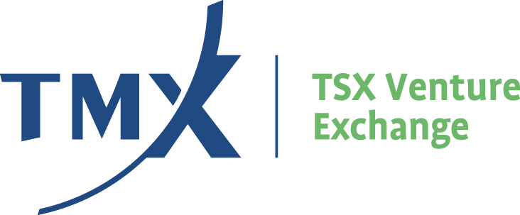

Appendix 3D

Non-Fire Assay Results
1. The veracity of precious metal assay results obtained by Issuers from foreign laboratories is a significant concern of the Exchange. The concern arises primarily due to the unreliable results produced by relatively unknown laboratories outside Canada incorrectly applying accepted industry techniques, using secret (“proprietary”) or unverified techniques, or employing unqualified staff.
2. Most analytic techniques for gold, silver and platinum group metals (“precious metals”) utilize the fire assay method to separate the metal from its enclosing rock. The final precious metal determinations are made by electronic balances or other instrument techniques. These analytical methods have proven to be accurate, reliable and reproducible.
3. Other analytic techniques are available for determining precious metal content of samples. These methods, if conducted accurately and within technical limitations, can be confirmed by the fire assay method and vice versa. Examples of such methods are atomic absorption, cyanide leaching and neutron activation. A key element of any analysis is that it be conducted by thoroughly trained personnel in a well-organized laboratory utilizing adequate controls.
4. Certain Canadian provinces ensure high analytical standards by way of certification of assayers. Minimum education and experience levels are required to obtain certification. Similar requirements are not prevalent outside Canada. The Exchange is aware that most American states do not have assayer certification while some states providing certification do not impose requirements comparable to those of the Canadian provinces.
5. A few Issuers have used certain non-Canadian laboratories and reported significant precious metal values from their exploration programs. In most instances, it has been claimed that the samples are mineralogically complex and not susceptible to fire assay. In each situation of this nature, analysis of the allegedly complex samples at other laboratories using fire assay and other industry accepted techniques have failed to confirm significant precious metal content. In other instances, some laboratories using industry accepted analytical techniques have yielded erroneous results because of faulty procedures and unqualified analysts.
6. In view of the problems with non-fire assay techniques and non-Canadian laboratories, the Exchange requires that each news release, shareholder report or other public communication which includes precious metal results from an analysis by a non-Canadian laboratory, or from an analysis using any technique other than fire assay, contain the following information:
(a) the analytical method used to obtain the reported results;
(b) the name of the laboratory at which the analyses were conducted; and
(c) the results of any fire assay check program or the intention to conduct a fire assay check program at an independent laboratory. All results of a fire assay check program are to be published in a timely manner.
7. An Issuer issuing a news release without the foregoing minimum information can be subject to a halt in trading pending clarification in another news release.
8. The Exchange can require an Issuer to undertake a fire assay check program at a Canadian laboratory if the reported results are, in the Exchange’s opinion, inconsistent with historic results from the property, the geological environment or other pertinent factors.
See Appendix 3F for Mining Standards Guidelines.

